Business Plan

1. **High-Level Pitch**

**Gamers/Spiritually-inclined - Anime – Dan Dani Dan Biggest Netflix anime show ever about two teenagers who obtain supernatural powers and fight Japanese demons**

**Teach what people who don’t have a spiritual mom – ancient knowledge, not religious but multiple truths of ancient civilizations and hidden knowledge/the questions of life**

**Spiritually–inclined feedback loop on decisions**

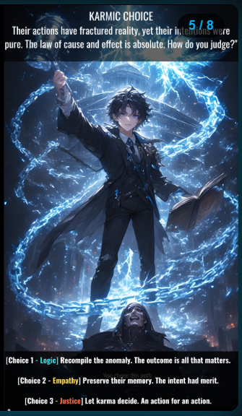

*Battle Eternal* is a multimedia franchise blending **myth, spirituality, and gaming**. Our roadmap launches from **storytelling (digital comic + lore)** into **interactive experiences (card game / RPG-lite)**, and ultimately scales into a **full Ready-Player-One-style ecosystem** that teaches real skills while entertaining.

We start small, but every step builds toward the long-term vision.

**2. Go-To-Market Strategy (Phased)**

**Phase 1: Story & Community Foundation**

* **Deliverable:** Digital Comic Book / Visual Novel (pilot episode)
  + Serves as *storyboard* for Season 1.
  + Distributable on **Medium, Patreon, YouTube (animated panels)**, product hunt
  + Collects early adopters & community feedback.
* **Marketing Channels:**
  + Medium (manifesto + lore drops)
  + YouTube (Episode 0, “Quantum Fracture” short film)
  + Reddit / Spiritual + Gaming groups
  + Patreon (early supporter content)
* **Funding Options:** Kickstarter for *collector comic + NFT tie-in*.

**Phase 2: Interactive Pilot Game**

* **Option A: Alex Card Game (TCG Lite)**
  + Free “starter card” (sorting hat style, light/dark choice).
  + Digital + physical packs.
  + Early monetization via **Kickstarter pre-sales + NFT cards**.
  + Revenue Example:
    - 3-Card Pack – $9.99
    - Potions / Power-Ups – $1.99
    - Special NFTs – $14.99+
* **Option B: Roll20 RPG-lite Module**
  + Characters: Alex (DPS), DeMarco (AoE), Crystallis (Healer), Ares (Tank).
  + Cinematic cutscenes (OBS/XSplit overlay).
  + Low-cost way to showcase mechanics & lore integration.

(*Both options can coexist — Card Game is more monetizable, Roll20 is more “show don’t tell” for lore depth.*)

**Phase 3: Scalable Universe Expansion**

* 3D Visual Novel → VR game (spiritual skills, coding quests, mythic combat).
* Franchise grows like *Yu-Gi-Oh + Sandman + Ready Player One*.
* Revenue: digital items, NFTs, expansions, in-game learning pathways.

**3. Revenue Model**

* Digital Comic + NFTs
* Card Packs (physical/digital)
* YouTube Ads & Patreon Supporters
* Kickstarter & Crowdfunding (collector perks)
* Long-term: In-game economies & licensing

**4. Costs (Lean Startup Approach)**

* NFT minting ~$5 each (optional upsell, not core cost driver)
* Comic Art / Card Art (outsourced to proven artists, already in network)
* OBS / XSplit / Roll20 integration (low dev cost, time-intensive but doable)
* Website (Bill’s focus, content-driven storytelling hub)

**5. Team & Roles**

* **You (Ryan):** Business strategy, finance, creative optimization. Experience in startups, real estate, finance.
* **Key:** Creative lead (lore bible, imagery, character dev, coding background).
* **Bill:** IT & lore support, web development, campaign strategist, grounding in esoteric/spiritual content.
* **Extended Network:** Artists, card designers, devs for scaling.

**6. Why Now? (Investor Angle)**

* Exploding market for **transmedia franchises** (Diablo, Sandman, Yu-Gi-Oh, Magic).
* Nostalgia + spirituality + gamification = underserved niche.
* Crowdfunding/NFT adoption proves demand for “myth + collectible” IP.
* Low-cost entry point → high scalability with right capital.

**7. Key Investor Questions (You Can Ask Back)**

* What deal structures do you usually see at this stage (idea + deliverable)?
* Do you fund founder living expenses at early stages, or only post-prototype?
* What *non-capital resources* do you provide (web dev, game coding, marketing)?
* Which pilot deliverable do you think will be most compelling:
  + Digital Comic Pilot,
  + Card Game Prototype, or
  + Roll20 RPG-lite Demo?